‘We are not disabled by our disabilities but abled by our abilities’- Oscar Pistorius

South African sprinter Oscar Pistorius is already a multiple world record holder and Paralympic gold medallist in the 100m, 200m and 400m Paralympic events. Clearly, he has already achieved many victories in his young life. Recently he added another great and memorable victory to his record sheet, but this time it was a win in a courtroom, not on a running track.

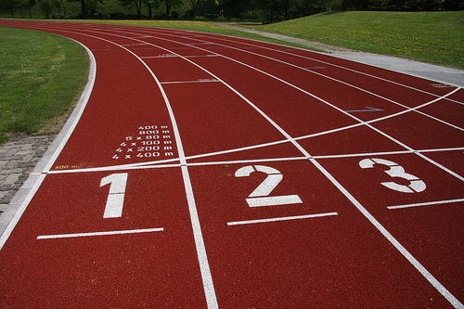
Image created by nchenga and reproduced under a Creative Commons licence.

BACKGROUND

Oscar Pistorius was born with a congenital disorder, which required the amputation of the lower part of both legs at the age of 11 months. Despite having no lower legs, Oscar went on to establish a successful sports career at school and university, playing rugby, water polo and tennis. He started running track during rehabilitative work for a rugby injury, and quickly realised that he had a special talent for the sport.

Pistorius went on to dominate the Paralympic podium in the 100m, 200m and 400m events,

also competing against, and beating, many elite able-bodied runners in races such as the 2007 South African Championships (which he won) and the Golden Gala in Rome.

Pistorius was clocking a running time that was moving him closer and closer to the Beijing Olympics qualification time. Having no legs couldn’t stop him from chasing his Olympic dream: instead, it was the International Association of Athletics Federations (IAAF) that would prove the only hurdle that would block his way.

THE LEGAL CASE: Pistorius v the IAAF

Having seen Pistorius edge ever closer to Olympic 200m qualification time, the IAAF banned Pistorius from competition, citing the competitive advantage gained from use of his prosthetics, or ‘cheetah’s’.

However, the IAAF had no evidence upon which to base the ban, and subsequently, accusations of discrimination were levelled against them, particularly as they had also vocalised controversial beliefs such as this: “It affects the purity of sport. Next will be another device where people can fly with something on their back.” (Elio Locatelli, Director of Development, IAAF). Subsequently, the IAAF announced that they would be happy to conduct research to back up their claims.

THE RESEARCH

The research was carried out at the German Sport University in Cologne (Institute of Biomechanics and Orthopaedics). The IAAF stated that test conclusions proved that Oscar had an unfair advantage. Subsequently, the IAAF upheld their ban, stating that Oscar’s prosthetics directly contravened their 2007 regulatory ruling, which prohibited technological aids on the competitive field (on the basis that springs, wheels or other such devices gave athletes with a disability an unfair advantage over athletes competing with their natural legs).

Pistorius immediately appealed the decision, taking his fight to The Court of Arbitration for Sport (CAS). The CAS agreed with Oscar, overturning the IAAF regulation. Whilst the debate continues to rage amongst some sectors of the sports world, it is nevertheless clear that legally, Oscar is free to run in the Olympics if he achieves the qualification time, and that the many disadvantages of using prosthetics might far outweigh any benefits in existence

CONSEQUENCES OF THE LEGAL BATTLE

Having faced a barrage of testing, media scrutiny and stress over the run-up to the Games, Pistorius had not been able to maintain the training schedule that might have allowed him to achieve qualification time. Although the South African Olympic Committee delayed finalizing their Olympic delegation to allow Pistorius a chance to qualify; the sprinter fell short of the 45.95-second Olympic qualifying mark for the 400m. His personal best time of 46.25s, achieved in Lucerne on July 16, was still not fast enough to get him on the start list for the 4 X 400m Relay team for South Africa. It is unknown as to whether he would have achieved this time without the court case hanging over his head; however, he did run proudly in the Paralympics and whitewashed the medal table, yet again.

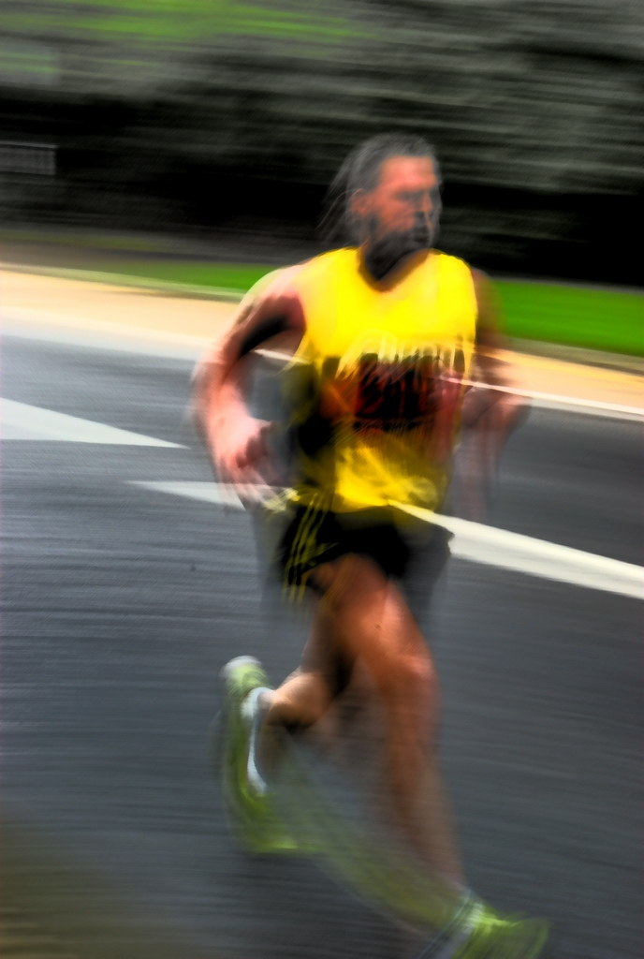
Image created by Sheffield Tiger and reproduced under a Creative Commons licence.

It will remain to be seen whether Oscar will qualify for the London 2012 Games. Whilst this is yet unclear, one thing we can observe is that he raised the profile of disabled and Paralympic sport is a meaningful way, and redefined and challenged our conceptualisation of what ‘able bodied’ really means.

FIND OUT MORE
IAAF Website
http://www.iaaf.org

Paralympic Games website
http://www.paralympic.org

Ossur (creators of Oscar’s prosthetics)
http://www.ossur.com,

CREDITS
© Oxford Brookes University 2010. oxb:060111:000dd

This resource was produced as part of the 2012 Learning Legacies Project managed by the HEA Hospitality, Leisure, Sport and Tourism Subject Centre at Oxford Brookes University and was released as an Open Educational Resource. The project was funded by HEFCE and part of the JISC/HE Academy UKOER programme. Except where otherwise noted above and below, this work is released under a Creative Commons Attribution only licence.

Exceptions to the Licence
The name of Oxford Brookes University and the Oxford Brookes University logo are the name and registered marks of Oxford Brookes University. To the fullest extent permitted by law Oxford Brookes University reserves all its rights in its name and marks, which may not be used except with its written permission.

The JISC logo is licensed under the terms of the Creative Commons Attribution-Non-Commercial-No Derivative Works 2.0 UK: England & Wales Licence. All reproductions must comply with the terms of that licence.

The Higher Education Academy logo and the HEA Hospitality, Leisure, Sport and Tourism Subject Centre logo are owned by the Higher Education Academy Limited and may be freely distributed and copied for educational purposes only, provided that appropriate acknowledgement is given to the Higher Education Academy as the copyright holder and original publisher.



Reusing this work
To refer to or reuse parts of this work please include the copyright notice above including the serial number. The only exception is if you intend to only reuse a part of the work with its own specific copyright notice, in which case cite that.

If you create a new piece of work based on the original (at least in part), it will help other users to find your work if you modify and reuse this serial number. When you reuse this work, edit the serial number by choosing 3 letters to start (your initials or institutional code are good examples), change the date section (between the colons) to your creation date in ddmmyy format and retain the last 5 digits from the original serial number. Make the new serial number your copyright declaration or add it to an existing one, e.g. ‘abc:101011:000dd’.

If you create a new piece of work or do not wish to link a new work with any existing materials contained within, a new code should be created. Choose your own 3-letter code, add the creation date and search as below on Google with a plus sign at the start, e.g. ‘+tom:030504’. If nothing comes back citing this code then add a new 5-letter code of your choice to the end, e.g.; ‘:01lex’, and do a final search for the whole code. If the search returns a positive result, make up a new 5-letter code and try again. Add the new code your copyright declaration or add it to an existing one.

